**Pharma Sales Dash Board**

Sales task(1 to4)

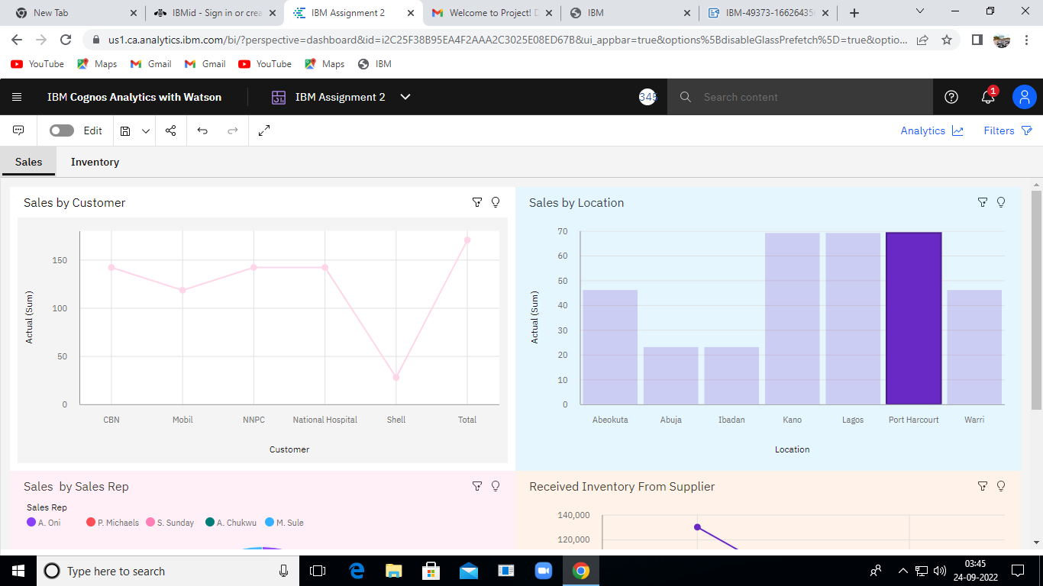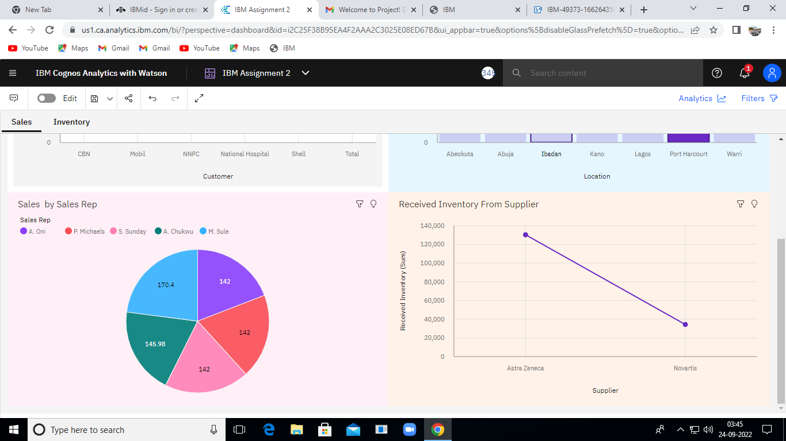

https://us1.ca.analytics.ibm.com/bi/?perspective=dashboard&pathRef=.my_folders%2FIBM%2BAssignment%2B2&action=view&mode=dashboard&subView=model000001836eec3567_00000002

Inventory (Task 5to 8)

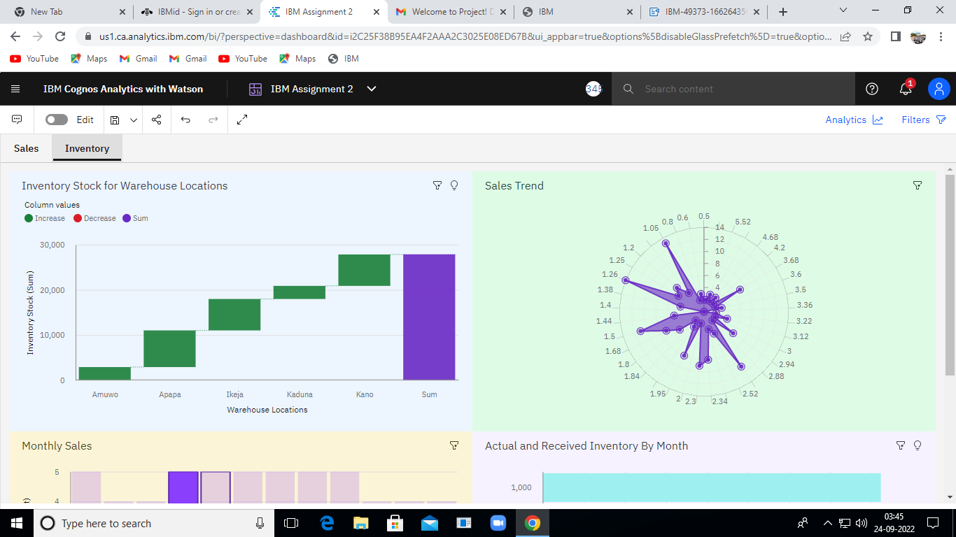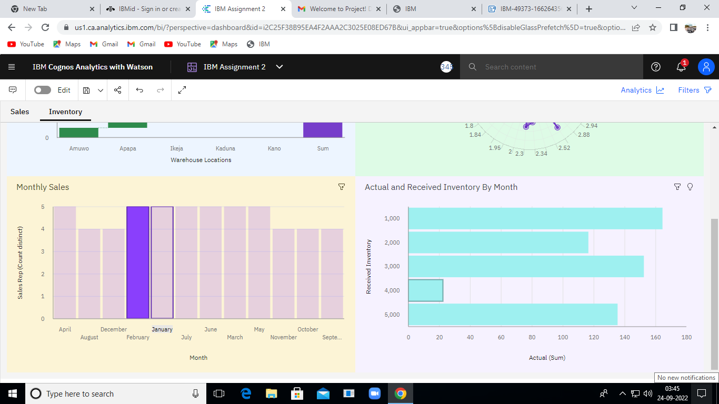

https://us1.ca.analytics.ibm.com/bi/?perspective=dashboard&pathRef=.my_folders%2FIBM%2BAssignment%2B2&action=view&mode=dashboard&subView=model000001836eff396d_00000000